**TO SET UP TWO FACTOR AUTHENTICATION For sender Email**

**Login to Gmail**

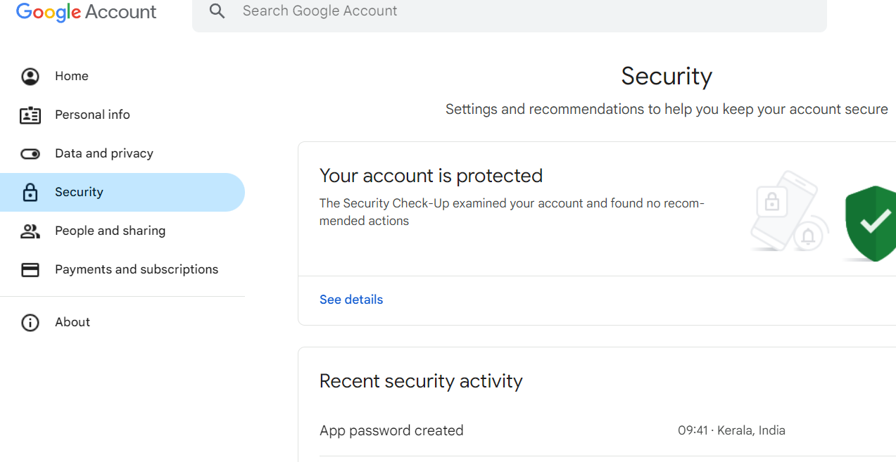

* **Secuirty**

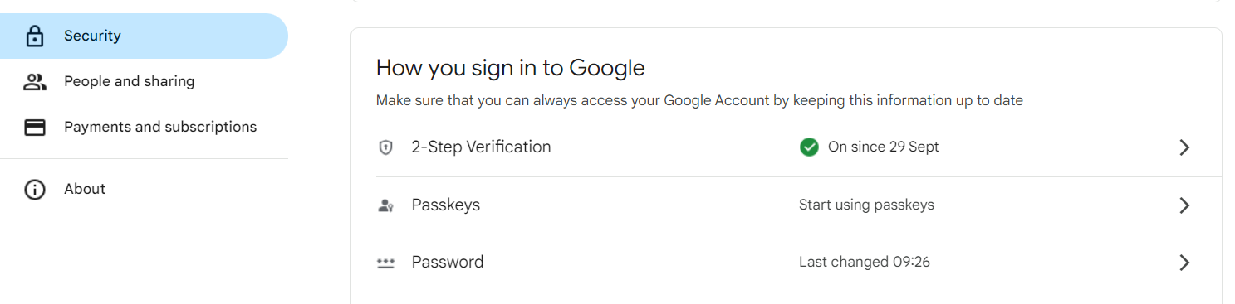

* **2-Step Verification**

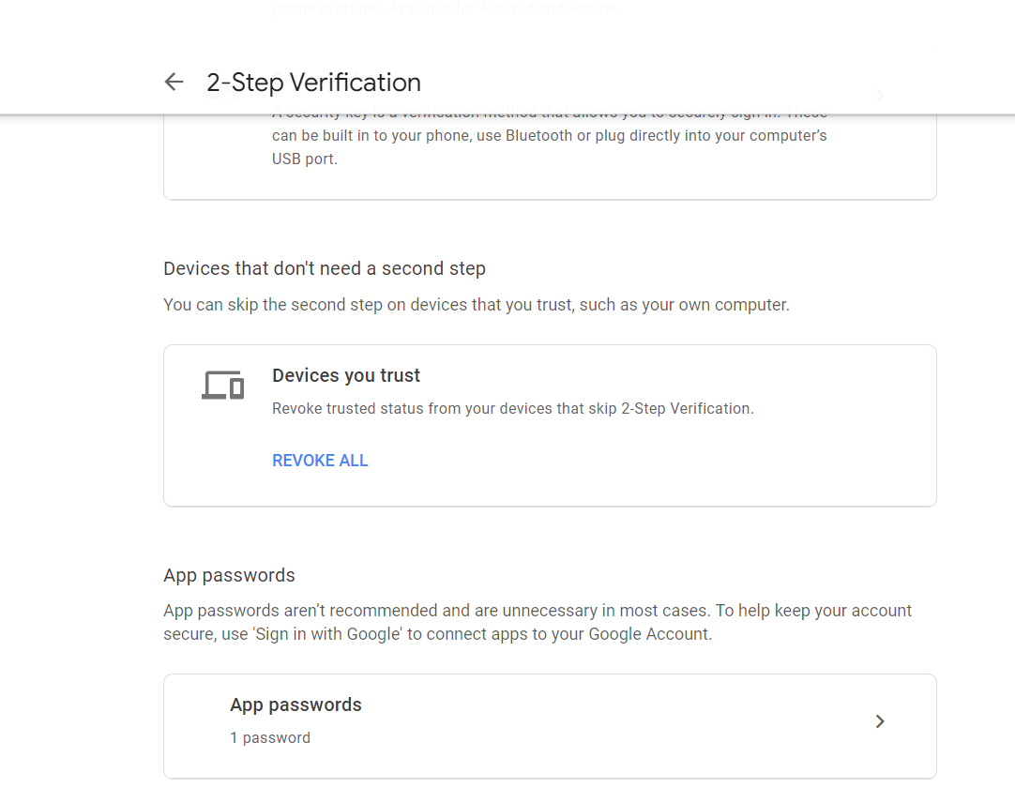

* **App passwords**

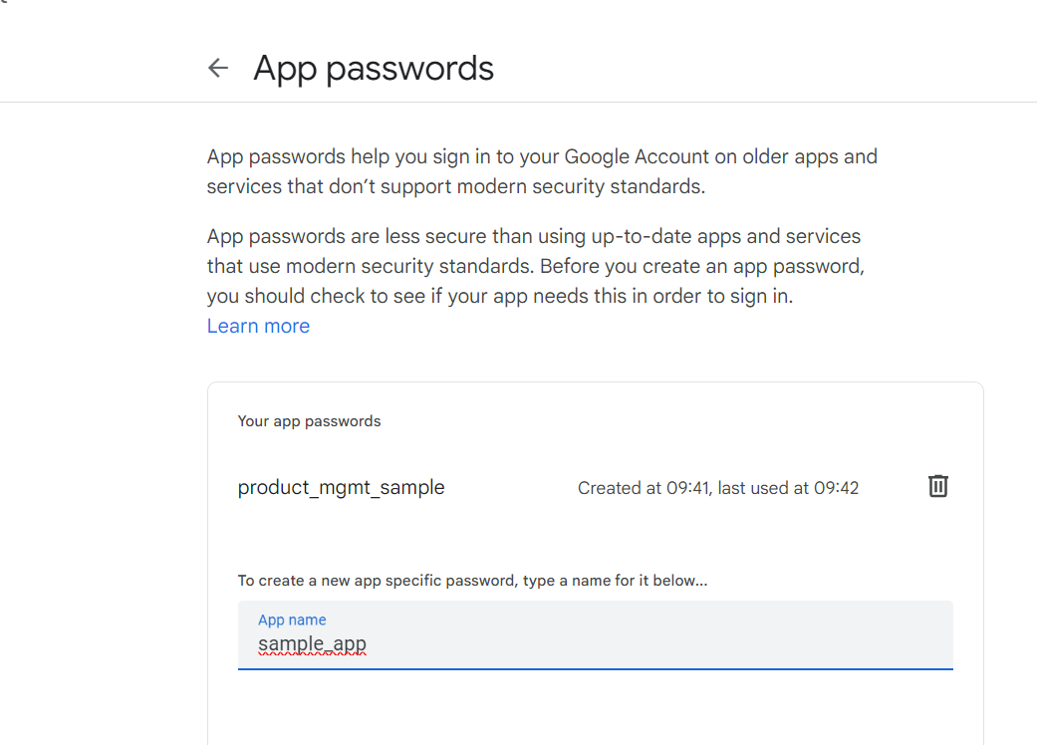

* **App name (any)**
* **Create**

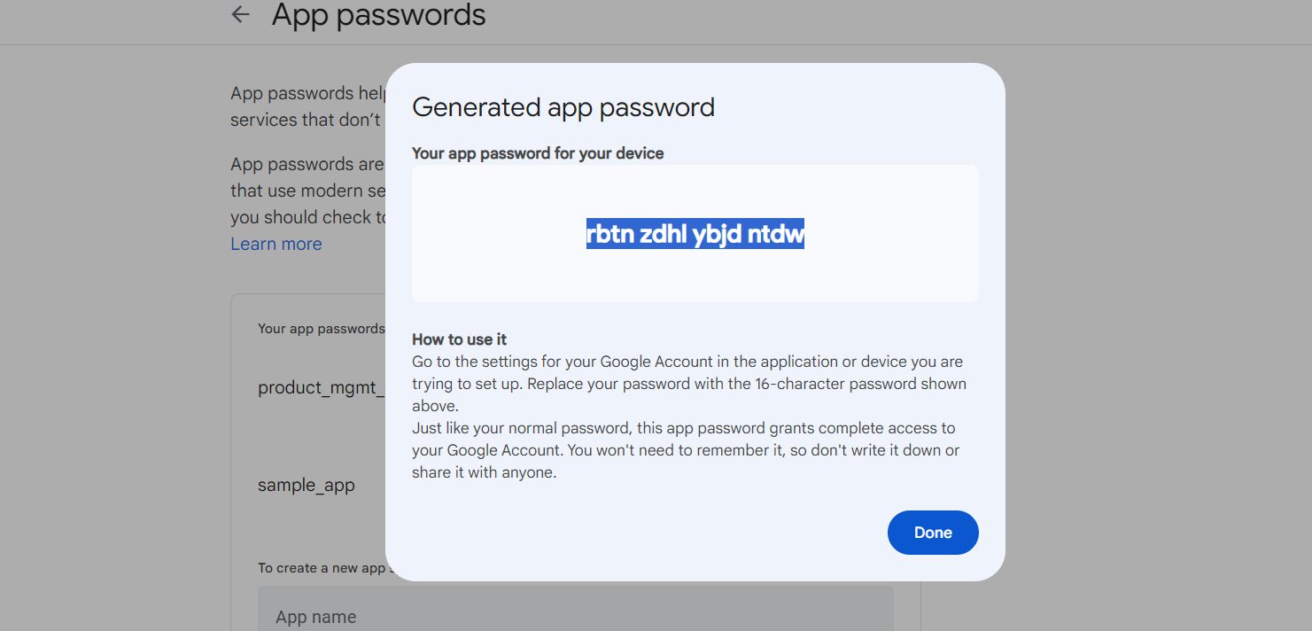

* **Copy app password**
* **Paste it instead of Gmail password as given below**



